**Date: 27/7/2022**

**Practical-1:**

**HPTLC: High performance thin layer chromatography**

**Aim:**

To quantitate DFS (Diclofenac sodium) from single formulation (Voveran) using High Performance Thin Layer Chromatography (HPTLC)

**Introduction:**

Chromatography is one of the techniques used for the separation of the components from the sample. Thin-layer chromatography is without doubt one of the most versatile and widely used separation methods in chromatography. The concept of HPTLC is simple and samples usually require only minimal pre-treatment. It has been frequently used in pharmaceutical analysis, clinical analysis, industrial chemistry, environmental toxicology, food chemistry, pesticide analysis, dye purity, cosmetics, plant materials, and herbal analysis. Today, most stages of this technique are automated and operated instrumentally in the form of modern high-performance thin-layer chromatographic system that allows the handling of a large number of samples in one chromatographic run. Speed of separation, high sensitivity, and good reproducibility result from the higher quality of chromatographic layers and the continual improvement in instrumentation. It is now capable of handling samples with minimal pre-treatment, detecting components at low nanogram sensitivities and with relative standard deviations of about 1%. HPTLC is now truly a modern contemporary of HPLC and GC and continues to be an active and versatile technique in research with large number of publications appearing each year.

The HPTLC technique is an automated and sophisticated form of thin layer chromatography with superior and advanced separation efficiency and detection limits and is often an exceptional alternative to high-performance liquid chromatography (HPLC) and gas chromatography (GC). The high-performance thin-layer chromatography is also known as flat-bed chromatography or as planar chromatography. The HPTLC works on the same principles as TLC such as the principle of separation is adsorption. The mobile phase or solvent flows through the capillary action. The analytes move according to their affinities towards the stationary phase (adsorbent). The higher affinity component travels slower towards the stationary phase. A low-affinity component travels rapidly toward the stationary phase. On a chromatographic plate, then, the components are separated. HPTLC technologies are also the most appropriate TLC technique for conformity with GMPs. HPTLC remains one of the most flexible, reliable, and cost-efficient separation techniques ideally suited for the analysis of botanicals and herbal drugs. Used with standardized procedures, it guarantees reproducible results, a vital element in the routine identification of complex fingerprints of plant extracts and pharmaceutical products. The use of modern apparatus such as video scanners, densitometers, and new chromatographic chambers, and more effective elution techniques, high-resolution sorbents with selected particle size or chemically modified surface, the possibility of combining with other instrumental methods, and development of computer programs for method optimization all make HPTLC an important alternative method to HPLC or gas chromatography. It has established itself as the method of choice for handling complex analytical tasks involving herbal drugs and botanicals. The unique combination of state-of-art instrumentation, standardized procedures, and solid theoretical foundations enables it to deliver reliable, cGMP-compliant results time after time.

**Diclofenac sodium** is non-steroidal anti-inflammatory drug (NSAID) which is used to treat minor aches and used as an analgesic to reduced pain. It is available as sodium and potassium salts. It is available as a generic drug in a number of formulations.

**Uses of Diclofenac sodium**

* Treatment of pain, inflammation disorders.
* It is used in treatment of various type of arthritis.
* It is also used in treatment of chronic disorder and acute non-bacterial inflammation of anterior part of eye.
* It is used in pain management in case of kidney and gall stone and also in case of active migraines.

**Side Effects**

DFS may cause side effects. Common side effects with DFS are stomach pain, constipation, diarrhea, heart burn or indigestion, headache, nausea, etc.

Contradiction: Hypersensitivity against Diclofenac inflammatory intestinal disorders such as ulcerative colitis, severe renal insufficiency

**Action of DFS**

It works by blocking the action of cyclooxygenase which is involved in production of prostaglandin. This prostaglandin produced in response to injury or certain diseases and would otherwise go on to cause pain.

**Principle:**

HPTLC works on the same principles as TLC such as the principle of separation is adsorption. The mobile phase or solvent flows through the capillary action. This separation relies on the relative affinity of compounds towards both the phases. The compounds in the mobile phase move over the surface of the stationary phase. It is based on the principle of adsorption chromatography or partition chromatography or a combination of both depending on the adsorbent, its treatment, and the nature of solvents employed. The compounds with higher affinity to the stationary phase will move slowly and the compounds with lower affinity to the stationary phase will move fast. Hence, the separation of the mixture is attained. On the completion of the process, the individual components will appear as spots at respective levels on the plates.

**Theory:**

Experimental Procedure of HPTLC –

1. Sample preparation: This requires a highly concentrated solution since much less sample quantity needs to be applied. The plate’s solvents must be non-polar of the volatile type. Polar solvents are commonly used to dissolve samples for reversed-phase chromatography.
2. Selection of Chromatographic Layers: The layer of HPTLC is available in the form of very fine particle size silica gel pre-coats which is widely used as adsorbent. The plates are similar to conventional TLC plates. Here silica gel of very fine particle size is widely used as adsorbent. The use of particle size helps in greater resolution and sensitivity. Plates are produced from 4 to 5 mm silica gel with an inert binder to form a 200mm layer. Plates of 20x20cms are 5x7.5cms is used.
3. Pre-washing: Plates need to be washed to remove water vapours or volatile impurities. The plated are cleaned by methanol.
4. Conditioning: The pre washed plates are placed in oven at 120°c for 15 to 20 mins. This process is known as conditioning.
5. Sample application: The size of the sample spot applied must not exceed 1mm in diameter. There are different techniques for the spotting of sample; one of them is self-loading Capillary in which small volume of samples may be applied to the plate. Surface using platinum- iridium tubing fused into the end of a length of glass tubing.
6. Pre-Conditioning: Saturation is necessary for highly polar mobile phases although there is no need for saturation for low polarity mobile phases.
7. Mobile Phase of HPTLC: Through trial and error, the mobile phase of the suitable solvents is to be selective.
8. Chromatographic Development: The linear development method in high-performance thin-layer chromatography is the most common technique here the plate is positioned vertically in an appropriate container with a solvent or mobile phase. The mobile phase is generally fed by capillary action and both sides may produce chromatograms.
9. Detection of spot and Scanning: The HPTLC instrument has attached to computer and data recording devices. The development of spots is viewed as peaks at wavelengths of selected UV regions. The height and the area of the peaks are determined by the instrument and recorded as a percentage.

**Requirements:**

1. Apparatus
2. Standard ambered volumetric flask (50 ml),
3. Pipettes (1ml, 5ml),
4. Hamilton syringe (100µl).
5. Chemicals
6. Methanol (HPLC grade)
7. Miscellaneous
8. Mortar and Pestle
9. Voveran 50 mg tablet
10. Instruments
11. CAMAG HPTLC set up with visionCATS software
12. Automatic sample applicator

**Procedure:**

1. Sample preparation:

1. Take an entire tablet of Voveran and weigh it.
2. Crush it in a mortar and pestle.
3. Weigh it again and transfer the entire content to a standard 50mL ambered volumetric flask.

2. Plate development: A silica gel coated aluminum plate was used of pore size 60 and fluorescence at wavelength 254 nm (60F254) made by the brand E Merck.

3. Load samples and standards using an automated sample applicator.

4. Place the plate in a 20 x 10 twin trough chamber containing the mobile phase for 20 minutes.

5. Perform scanning and detection under UV light using visionCATS software.

**Chromatographic conditions**:

|  |  |  |
| --- | --- | --- |
| **Sr no.** | **Parameter** | **Specification** |
| 1. | Instrument | visionCATS Planar chromatography software |
| 2. | Stationary phase   1. Plate size 2. Plate type 3. Indicator | 1. 20 x 10 2. Silica coated aluminum sheet 3. Silica gel 60F254 (E. Merck) |
| 3. | Sample | Voveran tablet |
| 4. | Standard | Diclofenac sodium |
| 5. | Sample and standard volume | 10μL |
| 6. | Band length | 8mm |
| 7. | Track distance | Automated |
| 8. | Mobile phase | Toluene: Ethyl Acetate: Glacial Acetic acid (6:4:0.1 for a 10 x 10 plate) |
| 9. | Chamber size | 20 x 10 Twin trough |
| 10. | Saturation time | 20 minutes |
| 11. | Solvent front | 90mm (9cm) |
| 12. | Detection (λmax) | 281nm |
| 13. | Number of tracks | 10 |

**Observations and Results:**

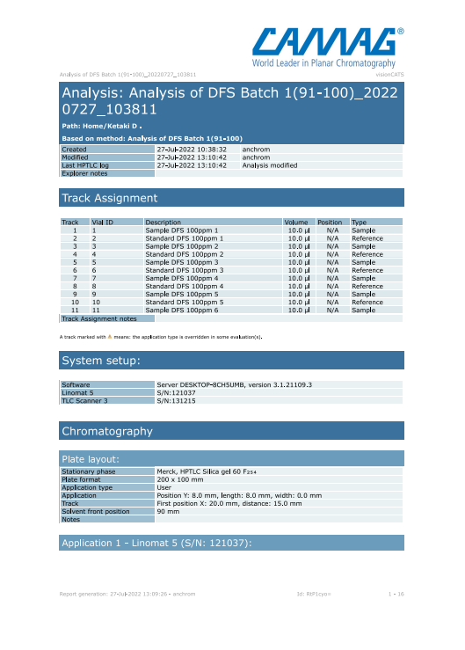

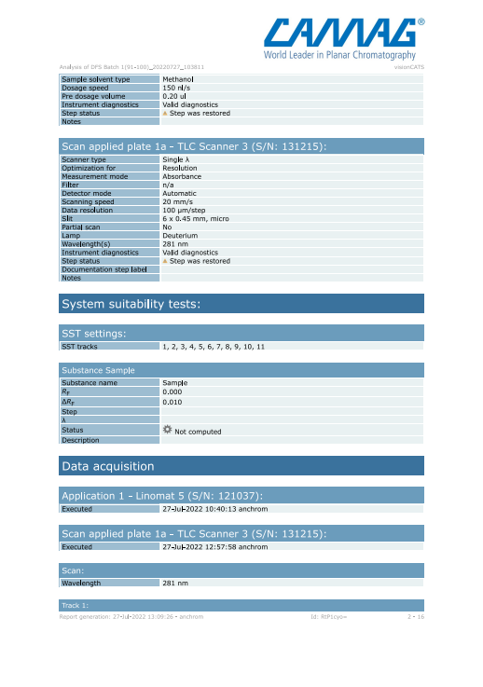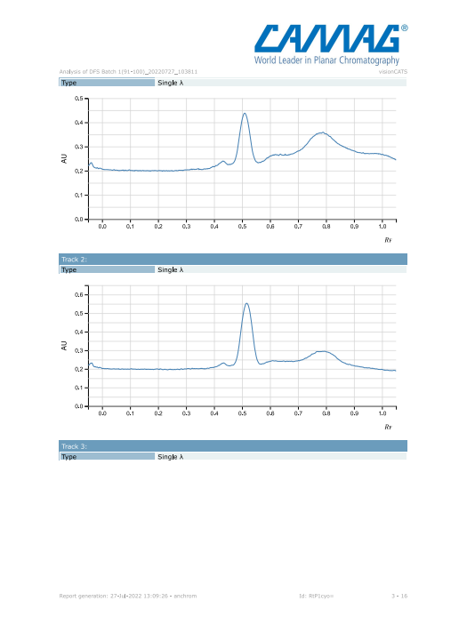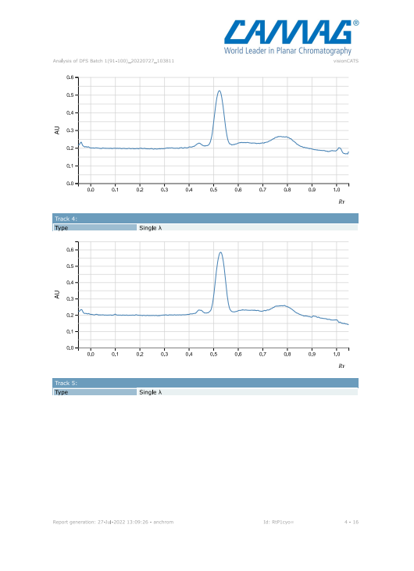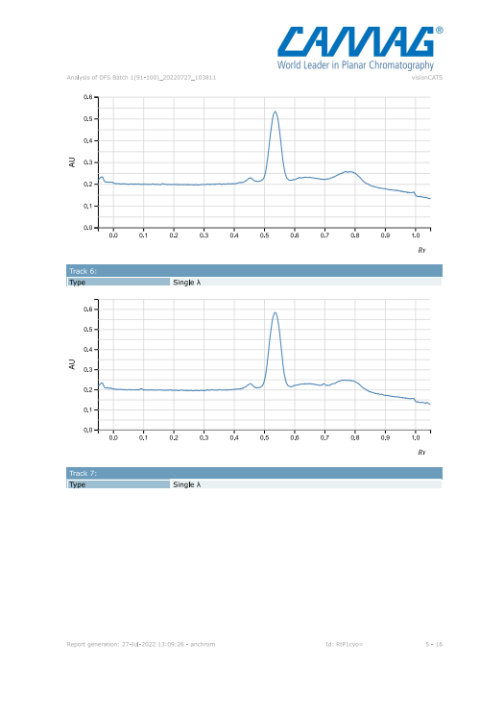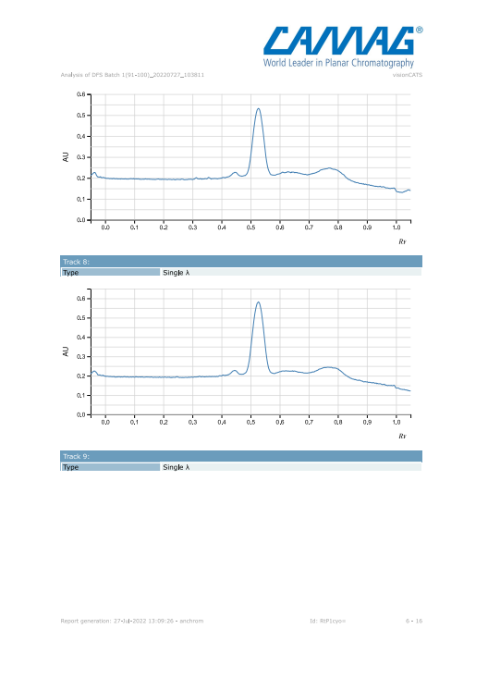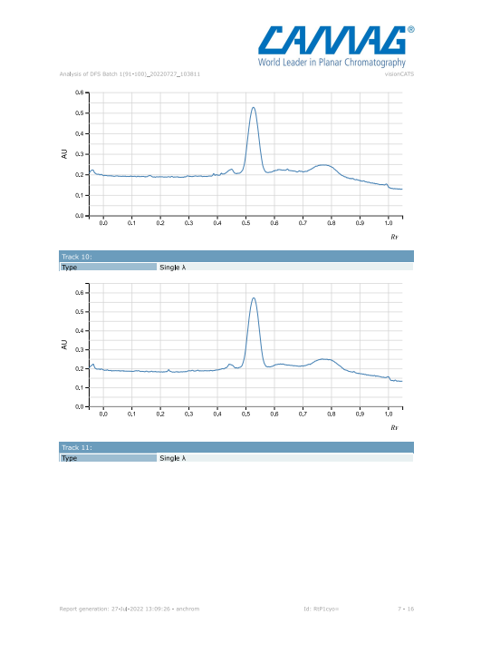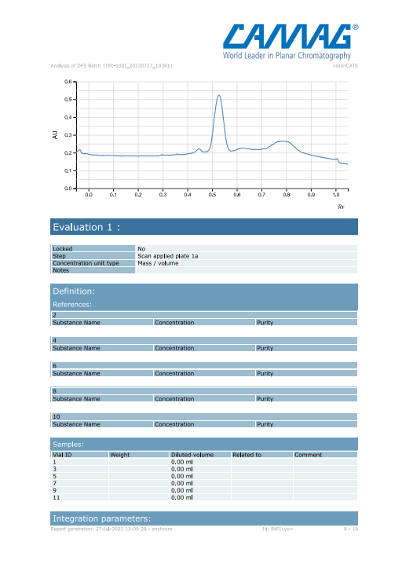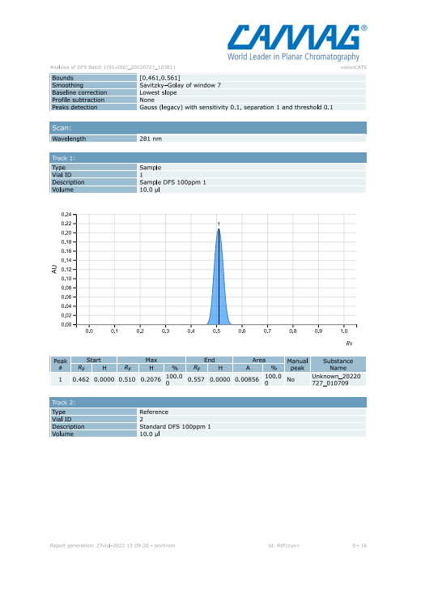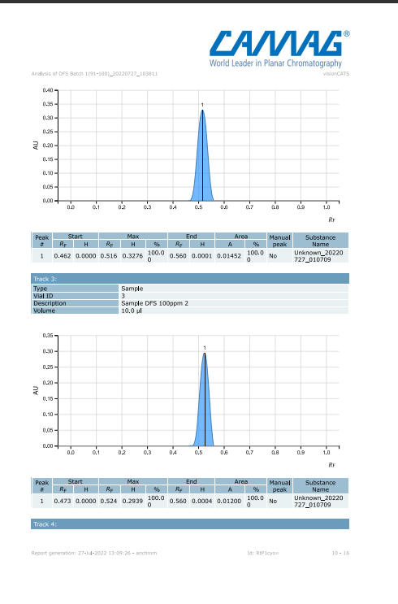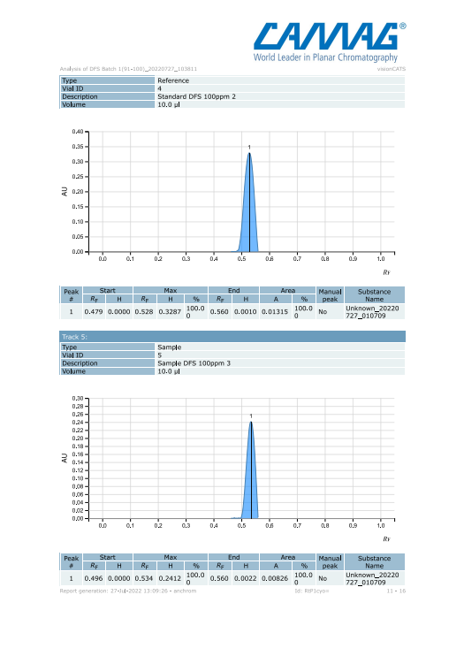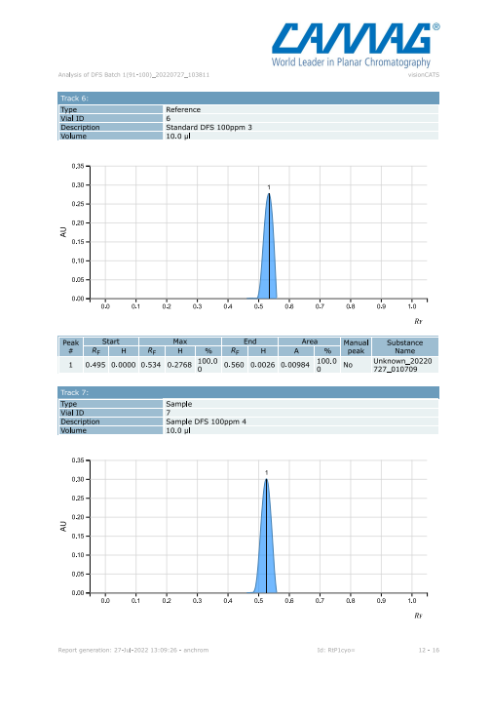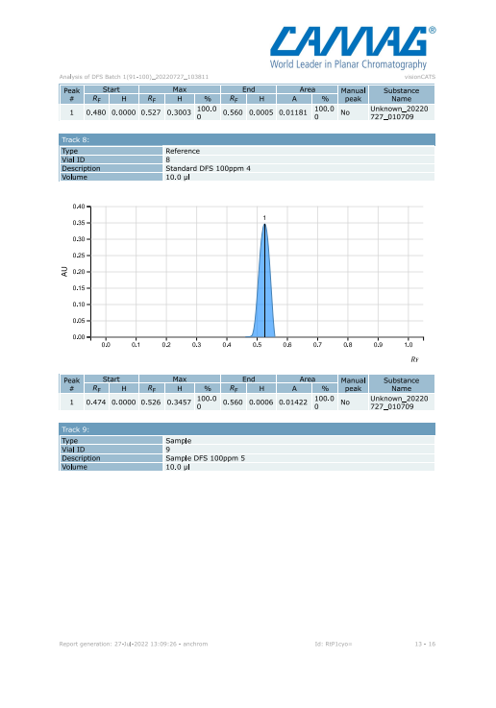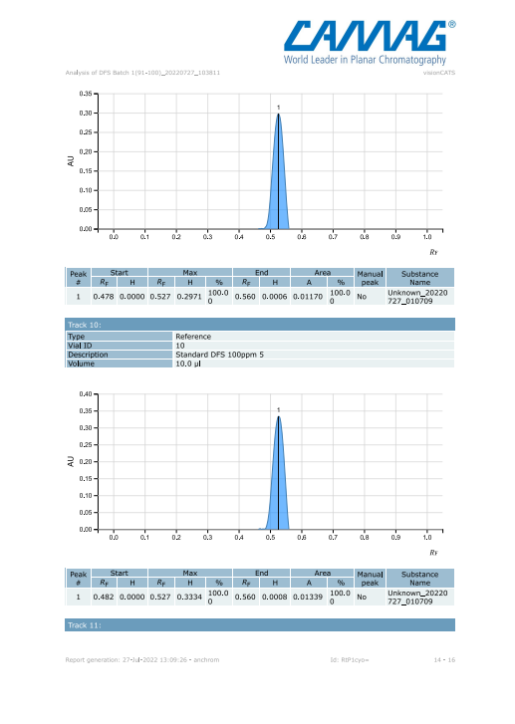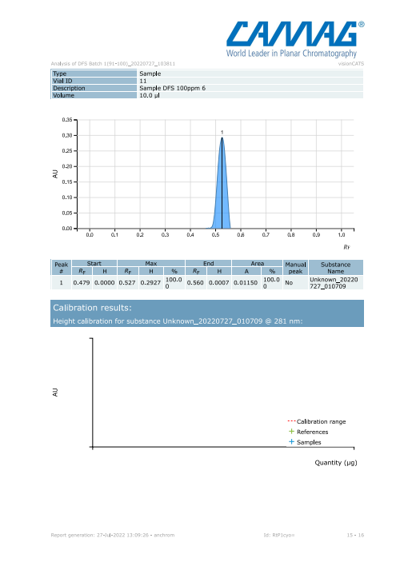

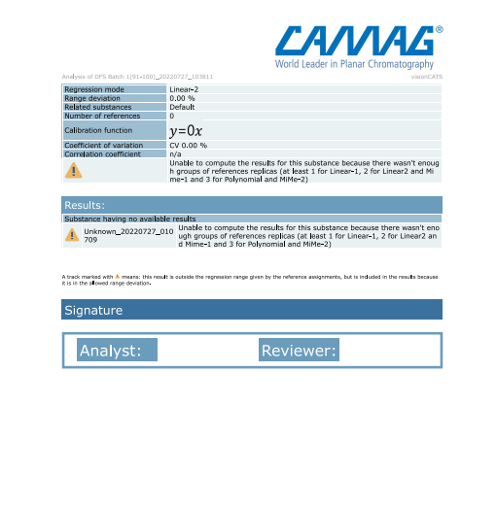

**Conclusion:**

Low cost, faster speed, satisfactory precision and accuracy are the main features of this method. DFS (Diclofenac sodium) was quantitated from single formulation (Voveran) using High Performance Thin Layer Chromatography (HPTLC).